Link to GUI/App design files:
- (available in sharepoint) Project PRS doc: HPWH (2H) Product Requirement Specification.docx
- (cannot find a BW location for where these are stored)
  - Figma design files (not linked to PRS): 2H Team File – Figma
  - Connection process from Kevin Smith - BW Wave Team File – Figma
  - Design file draft from Ketih Hemenway - Excalidraw
GUI perspective:
- Begin the process from either the main dashboard or the menu options.
    - Implementation for both of these are identical.
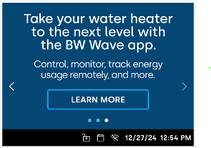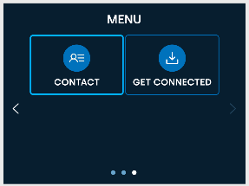
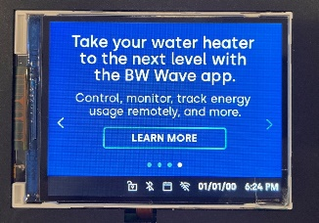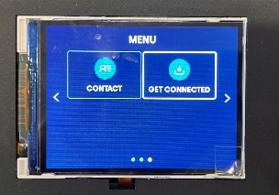
- Follow the prompts to (a.) connect or (b.) view a QR code link to the App Store
  - Connect or Get Mobil App screen: Implementation is identical, only difference is the small text takes 3 lines.
  - App QR code link screen: Implementation is similar, with updates made to clean up the text.
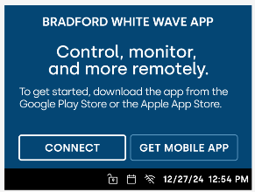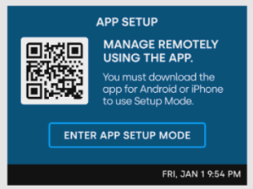
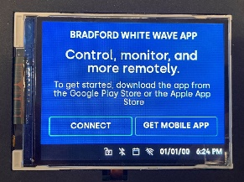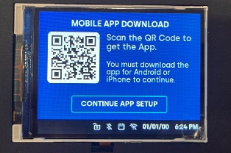
- Scan the QR code with the phone app.
    - Implementation is similar to the design but with better spaced text and QR code. Text was also cleaned up to streamline the process
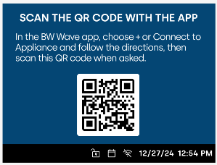
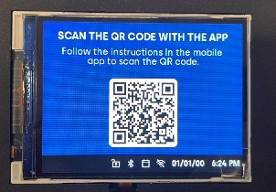
- Enter pin from the GUI in the phone app after scanning QR code (this establishes the Bluetooth connection).
    - No pin screen was designed, but the implementation is similar to the previous QR code screen, but with a rectangular box displaying the pin in place of the QR code.

- After entering the pin, the rest of the wifi connection process is left up to the App. You will see a screen that you may exit at any time.
    - Implementation is similar to this screen design, with added text telling the user that they may exit the screen.
